Phys 158 Notes
Christopher Kalitin

Jan 8 Reading Quiz
Light bulbs shine with voltage, not current. Higher voltage drop = brighter.

Connected in series = same current
Connected in parallel = same voltage

Series and Parallel are not geometric! They’re to do with current and voltage!

Current is defined as the flow of positive charges, ie. conventional current.

Jan 15 Lecture
Grounding allows you to specify values for the voltage at each point in the circuit. This is the ground truth that you measure against.

The negative end of a battery should be connected to ground, obvious but important. Think about it, GROK IT.

Ground is your reference! Do everything relative to it!

If there is no ground, you’re relative to the negative terminal of the battery.

Grounding allows you to join circuits without any unexpected currents between them.

Dielectric: having the property of transmitting electric force without conduction.
Dielectric: Electric fields but not conduction

Q is proportional to V
Charge stored is proportional to the potential differences over the terminals.

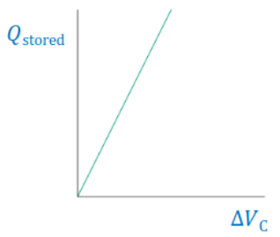

Tutorial 1 notes
To solve a question using Kirchhoff’s laws, first pick arbitrary directions for all currents on all wires. Then, draw in the loops, then for each loop get the equation. Solve the equations as a matrix, then just the junction law to solve for currents, then get directions (negative currents), then done.

Homework 1 notes
Capacitor discharge function: V = V₀e^{-t/RC}

Capacitor charge function: V = V₀e^{-t/RC}

Homework 3 notes
Power factor at resonance is 1. Since Z² = R² + (X_{L} - X_{C})²

Lots of good shit in this homework, I enjoy it immensely.

Resistance = actual energy dissipation
Reactance = energy storage and release

Reactance is an imaginary quantity.

Inductive reactance leads (left), capacitive reactance lags (right).

Reactance shifts phase, which decreases power since V and I aren’t at ideal values to max power.

Feb 23 Reading Quiz
In equilibrium, the electric field inside a conductor is zero. Equilibrium means none of the charges are moving, which of course means the field is zero. Charges move until the field is zero, then you get equilibrium.

If displacement of a particle is parallel to the force acting on it, the electric force is positive and there is a loss of potential energy. Simple but important to understand!!

Feb 26 Lecture
The electric field inside a conductor is always zero.

Because of Gauss’s law, all excess charge is distributed on the conductors output surfaces.

The only way you get charge inside a conductor, is if there is a charge separated by an insulator (air) inside the conductor in a cavity.

Surface charge density is largest when radius of curvature is smallest. This is also why electricians long ago would probe charged surfaces with the back of their hands, not a finger. Useful for trampolines too.

Potential energy is stored work.

Mar 12 Lecture
All charges create electric fields around them, then when they move you get a magnetic field.

RHR is standardized on positive charges.

Because force only acts orthogonal to velocity, the energy of a particle in a magnetic field is not changed. Remember! The dot product of a cross product is zero! Hence, cos(theta) = 0

Cyclotron motion: v stays constant but the vector changes.
A particle in a magnetic field going in a circle:
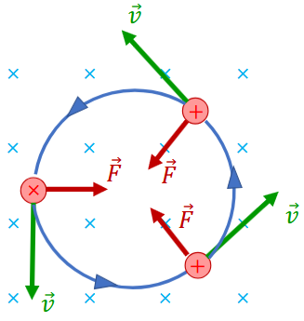

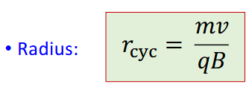
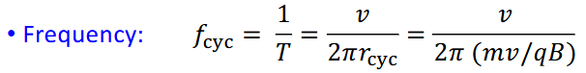
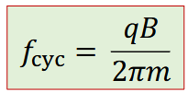

Note that frequency doesn’t depend on velocity, only on the charge, mass, and magnetic field. V cancels out.

Cyclotrons have two Dees of opposite charges. With a constant magnetic field, particle velocity is kept constant. By switching the polarity of the Dees, you get acceleration when the particle is between the two dees (electric force). On the next go around, you switch polarity to get more acceleration. Radius increases with velocity.
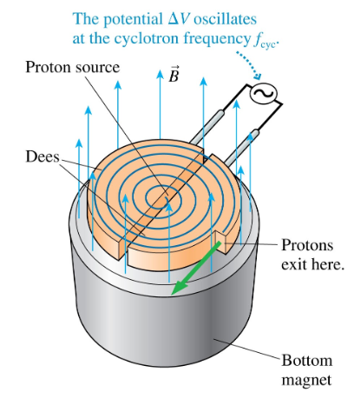

Lorentz force is the sum of electric force and magnetic force.

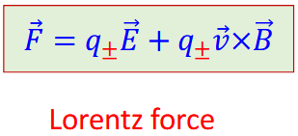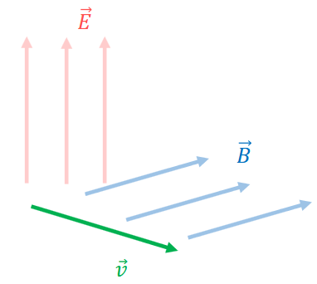

Mar 17 Lecture
Right hand rule for magnetic force from current loops:
Curl your fingers with the flow of currents.
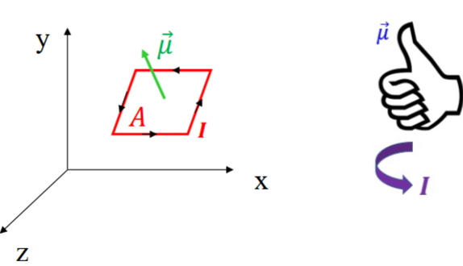

Tau represents magnetic torque:
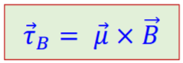

Mue is the normal vector of the current loop, B is the magnetic field vector.
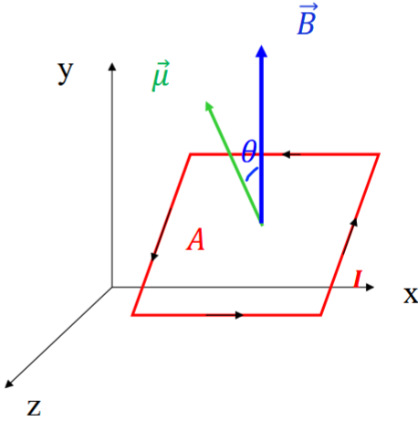

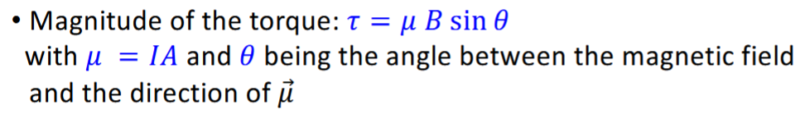

Magnetic potential energy is the dot product of mue and the magnetic field vector.
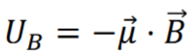

A more intuitive understanding of this is that more rotation to align mue with the magnetic field vector means more potential energy.

The hat symbol differs from the vector symbol because it represents a unit vector. Magnitude 1.
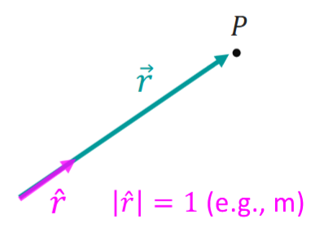

Curl your fingers from the current vector to the direction vector to find where your thumb points with the magnetic force.

Curl current to direction!!

No, even simpler, thumb in the direction of current, curl fingers with field.

Mar 19 Lecture
